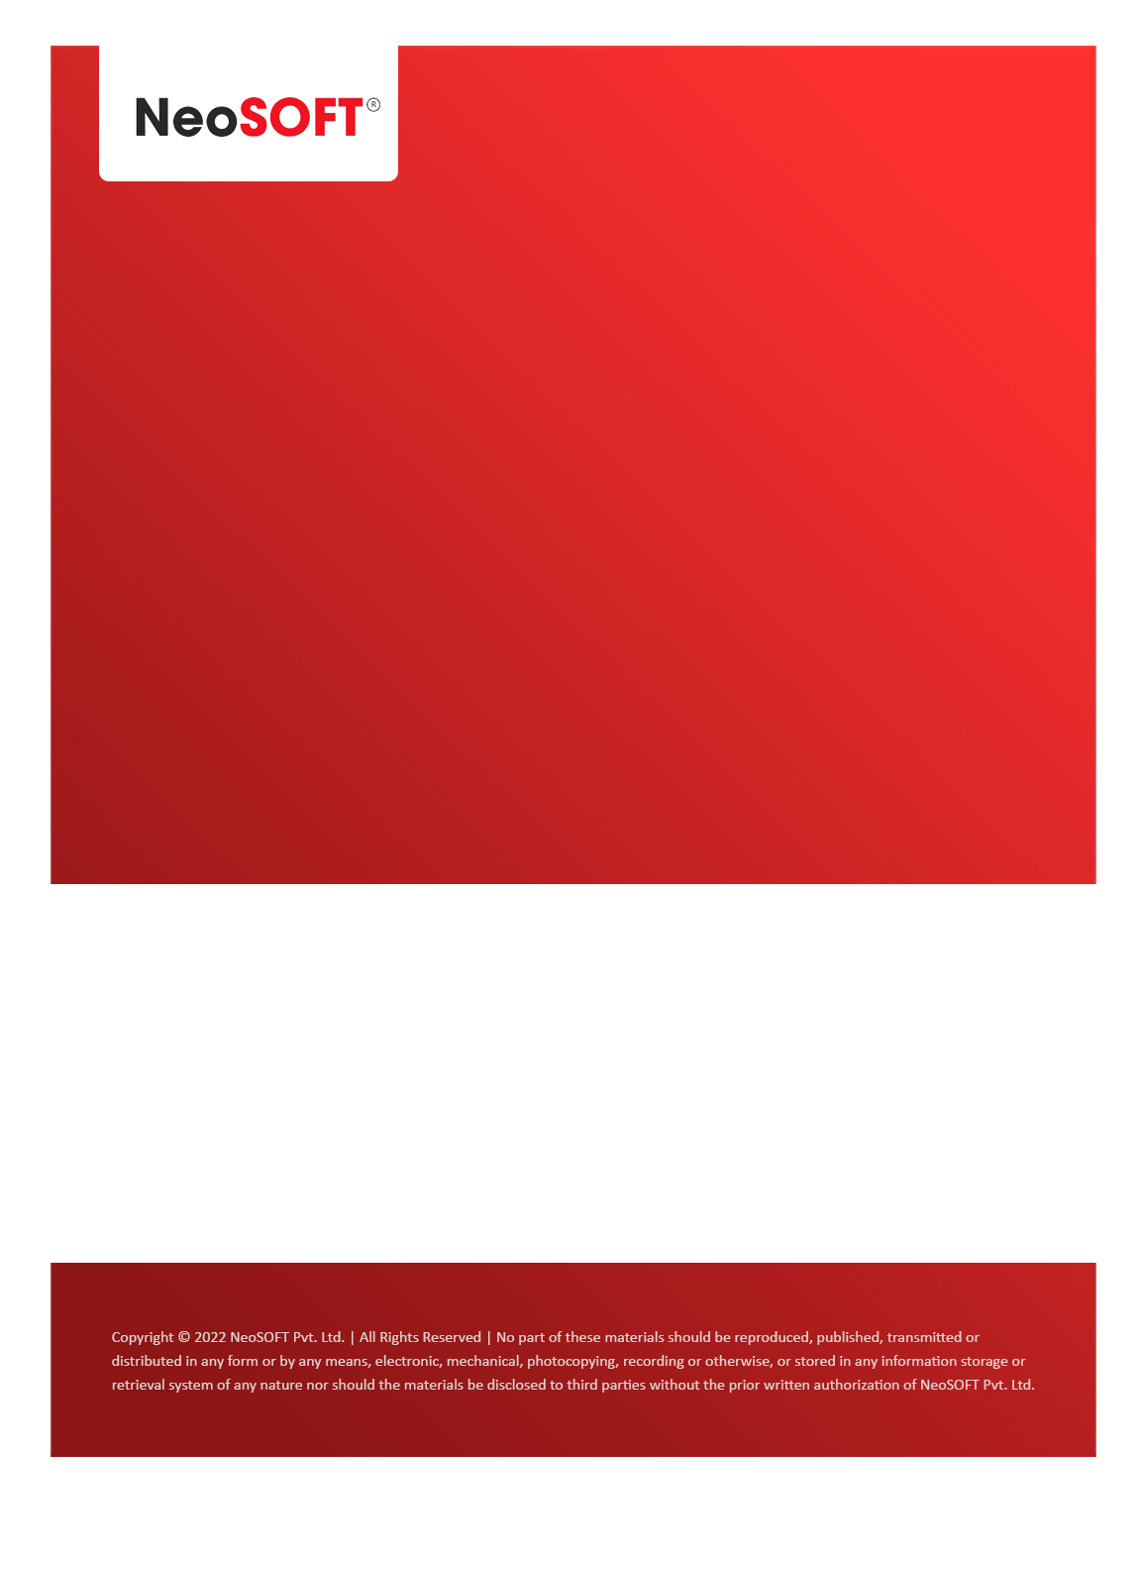`

**Eltizam MOM – Project Status meeting**

Eltizam

Client Name

NeoSOFT is a SEI-CMMI Level-5 Global IT Consulting & Software Solutions Provider

**May 25,** 2023

|  |  |
| --- | --- |
| **Meeting Date, Time, and Attendee Details** | |
| **Date** | 25th May 2023 |
| **Venue** | MS Teams |
| **Time** | 04.00 PM – 04.30 PM IST |
| **Meeting Type** | Wireframes, SRS document updates, Project status |
| **Internal Attendees** | * YallaReddy * Akshata Shinde * Nikita Lomate |
| **Client Attendees** | * Karuna Pawar * Vinod Kumar |
| **Presented By** | * YallaReddy * Akshata Shinde |
| **MOM Prepared By** | * YallaReddy |

|  |  |
| --- | --- |
| **Details of Meeting** | |
| **Sr. No.** | **Description** |
| 1 | Discussed pending feedback statuses on submitted wireframes. |
| 2 | Also, discussed to have meeting with Khateeb separately regarding Angular CR. We will do with Angular TL and Khateeb. |
| 3 | Waiting from Karuna to get information on   * Evaluation Assessment form * Invoice receipt * Payment receipt details. |
| 4 | As per Vinod’s confirmation, we will assume that most of master modules will be same and we will for writing SRS documents on them. We will submit SRS documents to Vinod & team once master modules are completed. |
| 5 | We will get Evaluation processes wireframes feedback from Vinod & team by Monday or Tuesday. |
| 6 | Also, informed to Vinod regarding effected delivery timeline of the project because of current delay in phases. |
| 7 | Akshata showed sample SRS document format to Eltizam team & we all are on same page for the SRS. |

|  |  |  |  |  |  |
| --- | --- | --- | --- | --- | --- |
| **Actionable** | | | | | |
| **Sr. No.** | **Action Item** | **Assigned to** | **Assigned Date** | **Expected Completion Date** | **Status** |
| 1 | Vinod will check and confirm review comments on wireframes by Monday or Tuesday (30th May). |  |  |  |  |
|  |  |  |  |  |  |
|  |  |  |  |  |  |